Description of A Modified Prognostic Cloud Scheme

Minghua Zhang
SUNY at Stony Brook

July 9, 2001

Basic Equations

The controlling equations are

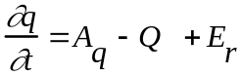 (1)
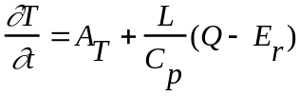 (2)
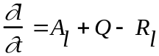 (3)

where 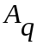,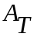,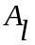 are tendencies of water vapor, temperature, and cloud liquid water from processes other than condensation, evaporation and cloud microphysics. For simplicity, we call them advective tendencies. is the cloud liquid water content, 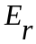 is the evaporation of rain, 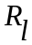 is the conversion rate of cloud water to rain water. is the grid-averaged net condensation of cloud water (condensation minus evaporation). The task is to calculate when a grid box is partially cloudy, and to calculate the corresponding partial cloud amount.

The relative humidity can be written as
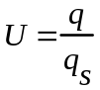
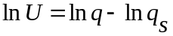
and thus
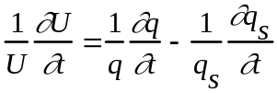
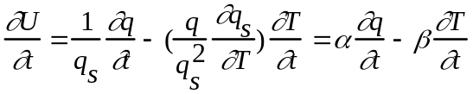 (4)
where
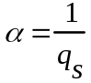 (5)
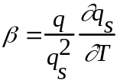 (6)

Substituting (1) - (2) into (4), one gets
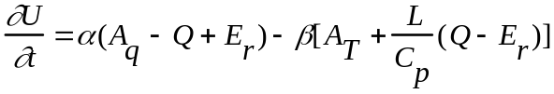
or
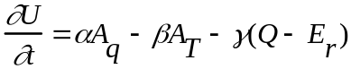 (7)
where
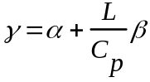 (8)

Equation (7) describes the following physics: moist advection (positive ), cold advection (negative ), and net evaporation of cloud and rain (negative 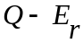), all lead to increase of relative humidity. ,, and can be viewed as efficiencies of these three processes in changing the relative humidity . They are calculated from (5), (6) and (8).

The above equations are applicable on both sub-grid and grid scales.

Note 1: Saturated air
For sub-grids that remain saturated before and after the condensation, 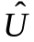=1, and 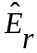=0, where the hat denotes the saturated portion. Equation (7) becomes:

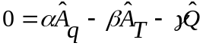 (9)
Thus, the net condensation for this portion of the grid is entirely described by the advective tendencies of and :
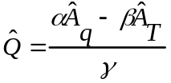 (10)
could be negative to describe expenditure of the existing cloud water from evaporation. Using (3) for the saturated portion of the grid box:
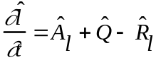
together with (10), the rate of change of cloud liquid water can be written as

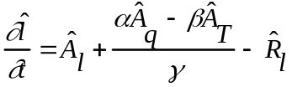 (11)

Note 2: Comparison with the Rasch and Ekristjansson (1998) 1st Closure

From (10), contribution of the saturated portion to the grid-scale condensation 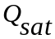 is
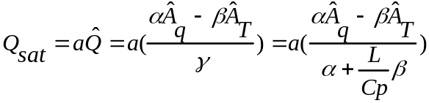 (12)
where is the cloud fraction.

In Rasch and Ekristjansson (1998), where different notations were used, their first closure assumption (equation 10 in their paper) implied a form of
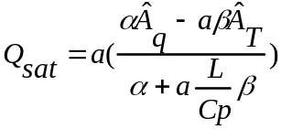 (13)
The difference between (12) and (13) is in the appearance of the cloud amount a. When a is equal to 1, the two formula give the same results. When a equals to 0, the terms within the parentheses can differ a lot, but since they are multiplied by a, again the two formula give the same results. When a is neither 1 nor 0, there are differences. The largest difference is expected when a is about 0.5 and when the magnitude of is much larger than that of . Formula (12) is easily understood from the basic physics as described above, but formula (13) is an assumption.

Note 3: Formulation using total water and liquid water temperature

To facilitate later comparison with the statistical cloud schemes (eg., Smith (1990) and LeTruet and Li (1988)), the basic equations (1)-(3) can be re-written as:

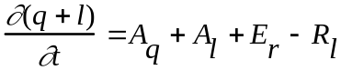
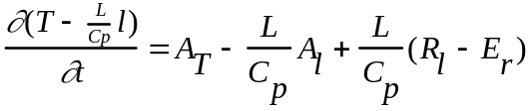
Using the total water and the liquid water temperature:
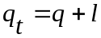 (14)
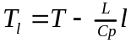 (15)
the above equations are:

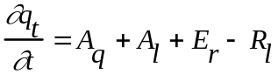 (16)
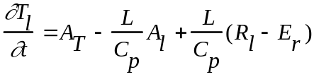 (17)
Since Q does not appear in the above equations, 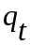 and 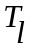 are conserved in the process of cloud condensation and evaporation.

At any sub-grid, and completely determine q, T, and the cloud liquid l through the following:

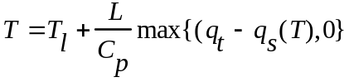 (18)
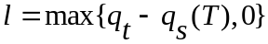 (19)
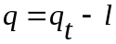 (20)

Assumption on sub-grid scale variability

Assuming that the fractional cloud amount is related with the grid-scale relative humidity, then
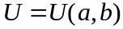 (21)
where a is the fractional cloud coverage and b denotes a generic variable that describes the sub-grid scale variability of T and q. This equation is assumed to be valid when U is larger than a threshold value 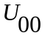, which is the minimum grid-scale relative humidity with clouds.

Based on the relative humidity equation of (7), this relationship between cloud cover and grid scale relative humidity implies:
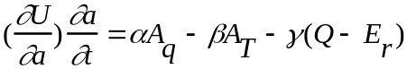
Define
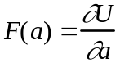 (22)
The above equation becomes
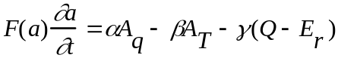 (23)
F(a) describes the sensitivity of the grid scale humidity to the fractional cloud coverage. Since (21) is valid only when U reaches a minimum humidity , (23) is valid for 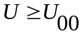. When 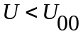, no cloud exists.

We can use the current CCM cloud scheme as (21).

Note 1: The Sundqvist Scheme

In Sundqvist (1989, 1990), grid scale U is written as the weighted average of cloudy sky relative humidity 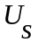(=1) and clear sky relative humidity 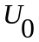:
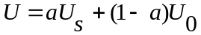 (24)
and the clear-sky relative humidity is parameterized using cloud cover as
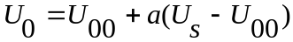 (25)
where is a constant (80%). is the minimum relative humidity at which cloud starts to form. (22) and (23) give a relationship between U and a as
(26)
and
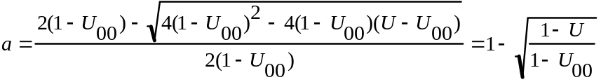 (27)
U increases with a monotonically between and 1. For a to be larger than 0, U must be larger than .

Note 2: Using probability distribution of total water

In schemes where probability distribution P(x) of total water is assumed,
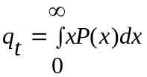 (28)
Fractional cloud cover is diagnostically calculated as:
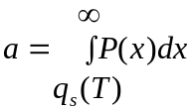 (29)
where 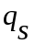 is the saturation water vapor mixing ratio. and T can be obtained by solving the following implicit equation
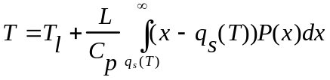 (30)
The relative humidity of the grid box is
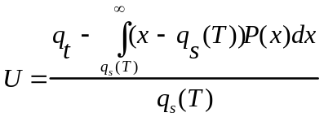 (31)

Thus, assumption of the probability distribution of total water P(x), and the existing total water and liquid water temperature and , completely determine the cloud fraction and the grid-scale mean relative humidity. There is therefore an implicit relationship between the grid-scale relative humidity and fractional cloud cover. Its exact form depends on the assumption on the probability distribution of P(x). In Smith (1990), where a triangular distribution of P(x) is assumed and its standard deviation is assumed to depend on the grid saturation mixing ratio, he derived an explicit relationship from (29) and (31) as (Appendix C in Smith 1990):
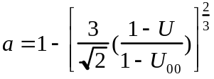 (32)
For other assumed P(x), this relationship can not be explicitly written, and it typically changes with and .

Note 3: More generalizations

One can also start with the sub-grid scale structures of T and q (say gravity waves, convection plumes, or simply linear functional fitting using neighboring grids), assuming them to be 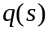, 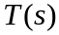, where 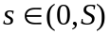 describes the horizontal coordinates within the grid box [ If the sub-grid structures are assumed for the total water and liquid water temperature (s) and (s), (18)-(20) can be used to calculate the sub-grid structures of , , and l(s)].

Cloud amount then becomes
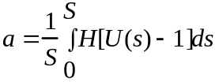 (33)
where U(s) is the relative humidity on the sub-grid scale
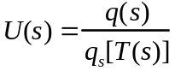
and H is defined as
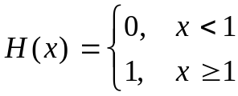 (34)
(35)
The grid-scale relative humidity is
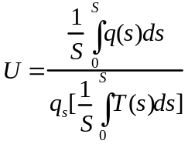 (36)
Again, given the sub-grid structures of T and q, the cloud fraction and the mean relative humidity can be determined, which in turn gives an implicit relationship between U and cloud amount a that forms the basis of (23).

Note 4: Actual calculation of F(a)

When the current CCM cloud scheme is used, the F(a) in (22) is calculated by calling the cloud routine twice with slightly perturbed relative humidity. Thus,
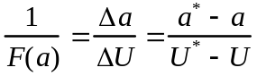

The Closure Equation

The grid-scale liquid water content can be written as
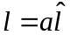
The cloud liquid water equation (3) for the whole grid then becomes
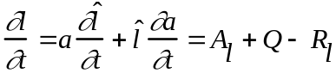 (37)
As described before, in the cloudy portion, the liquid water change is controlled by (11). (37) then gives an equation for the cloud amount change, which is related with Q:
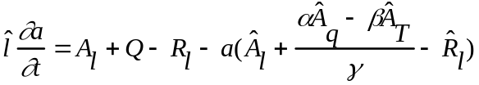
Since (cloud to rainwater conversion) takes place inside clouds,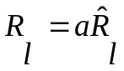. Assuming that the tendency terms inside and outside the clouds are the same, the above equation becomes
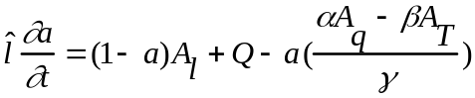 (38)

(38) and (23) form a closed set of equations for 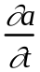 and Q. Eliminating Q, one gets
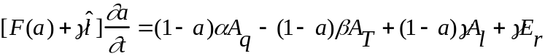 (39)
Eliminating , one has

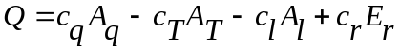 (40)

with
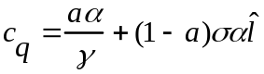 (41)
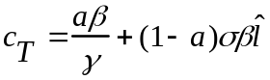 (42)
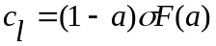 (43)
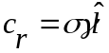 (44)
where
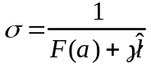 (45)
Except for 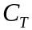 and with a unit of 1/K, all variables in (40)-(45) are non-dimensional. All are positive. Once Q is obtained, (1)-(3) can be integrated. Cloud amount can be either integrated from (39) or from the integrated T and q and thus U through (21). The two methods should produce the same cloud amount, that is, the prognostic cloud amount is the same as the newly diagnosed amount.

Physical interpretation of the cloud amount equation (39) is as follow: moist advection (positive ), cold advection (negative ) , evaporation of rain water (positive Er), and import of cloud liquid water (positive ) all lead to increase of cloud amount. The impact of , and Er on cloud amount is through the change of grid-scale relative humidity and (21) , with ,, and as efficiencies of these three processes multiplied by the clear sky fraction (1-a). Er can be written as 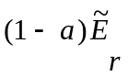, where the tilde denotes clear-sky since rain evaporation only takes place in clear-sky. The impact of on cloud amount is because it changes the grid-scale mean liquid water amount. On the left side of (39), both F(a) and 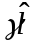 describe the efficiency of cloud variation in changing the mean relative humidity. With large F(a) and large in-cloud liquid water 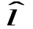, a small change of cloud amount can make a big change in U.

Physical interpretation of (40) is as follow: moist advection (positive ) and cold advection (negative ) produce condensation. Evaporation of rain water (positive Er) also produces condensation, because it changes the mean relative humidity, thus increasing cloud amount and cloud liquid. Import of cloud liquid water (positive ) leads to evaporation, because the cloud fraction is increased which requires higher clear-sky relative humidity from evaporation.

Note 1: Physical consistency

The net condensation Q in (40), with coefficients expressed as (42)-(45) can be derived from a different method. We can write the total heating to be a weighted sum of heatings in the cloudy-sky portion and in the clear-sky (plus boundary) portion of the grid box:
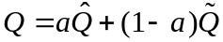 (50)
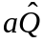 is the cloudy portion of the heating that has been described in (12). It is re-written here as
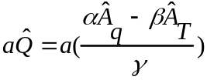 (51)
For the clear and boundary portion of the grid, one can write (23) as
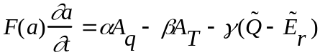 (52)
and the liquid water equation (37) as
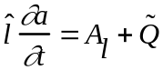 (53)
with consideration of a=0 and =0. Eliminating between (52) and (53), one gets
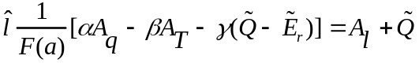
The above equation can be re-arranged to get:
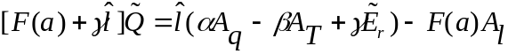
or using the variable in (45)
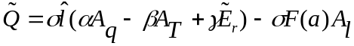 (54)

Substituting (54) and (51) into (50), one gets
(55)
This is exactly the same as (40). In the above, rain evaporation relationship 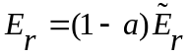 has been used.

Note 2: Sundqvist (1988, 1990) assumption

In the Sundqvist (1988, 1990) formulation, an equation similar to (38) was intuitively derived as

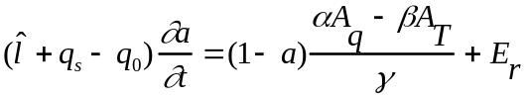 (56)
This is not based on physical derivation and it does not include the impact of cloud liquid water advection on the change of clouds. It shares some similarities with the correct form of (39).

Note 3: The Rasch and Ekristjansson (1998) assumption

In the Rasch and Ekristjansson (1998) formulation, a second closure (their equation 13) was used to calculate the clear-sky portion of the net cloud condensation. It may be considered as an approximation of equation (53), even though here and Q are coupled, while in Rasch and Ekristjansson (1998) and Q are decoupled. Because of the use of a pre-determined , in the actual implementation of the Rasch and Ekristjansson (1998) scheme, their equation (13) was used only when cloud is shrinking (to give moisture out), but not the when cloud is expanding (to take moisture).

Note 4: Q from probability distribution of total water

With assumed probability distribution of total water P(x), using (16)-(17) and the diagnostic relationship (30), one can derive the grid scale 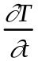 or 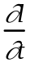, from which Q can be calculated. The input variables are the same as those in (40).

Note 5: Implementation procedure of the modified scheme

All one needs to do is to calculate the coefficients in (41)-(45) and then derive the Q using (40). It is then used in (1)-(3).

Further possible improvements

- Ice phase (and rain, snow etc) can be separately considered, the derivation is straightforward following the same procedures.

Equation (23) will be similar except that Q now represents the sum of the net water vapor conversion rate to all other phases (cloud water, cloud ice, rain water, snow, groupel), and Er describes the sum of conversion between the water phase and ice phase (all microphysical processes affecting temperature but not water vapor). Equation (37) is replaced by the total condensed water equation, and (11) replaced by a total condensed water equation within clouds. Again (23) and (38) forms a closed set of equations for prognostic cloud amount variation and the sum of net water vapor condensation. The scheme then provides a link to the CSU type of cloud microphysical treatments.

- Treat convection output as sub-grid scale information and incorporate output from a convection scheme into the cloud scheme through (37).

- Using sub-grid scale information to improve (21) as described in the notes of
Section 2.

Experiment Status

- Implemented in CCM3.12.8

- Tested in the CCM SCM mode using ARM IOP measurements.

- Tested in GCM runs.

- Codes written to conform with the new CCM standard.

What we found: the modifications to the cloud scheme do not make large changes on the simulated climate.

However, they have removed most of the arbitrary assumptions in the Rasch scheme, and provide a foundation for further improvements of the cloud scheme.

The condensational heating rate at the upper troposphere is slightly larger from the modified simulation than that from the Rasch scheme for reasons that can be explained from simple diagnostic calculations. This leads to slight reduction of high cloud amount and thus TOA cloud radiative forcing. When the the cloud-to-rain conversion rate is slightly reduced, the radiation budget is re-tuned to the original values.

Results from a five year simulation with the modified scheme are posted at http://climate.msrc.sunysb.edu/.

The codes are tar-ed in /home/blackforest/mzhang/ccm3.12.8+zcme.tar.gz.

The original PCOND.F90 of the Rasch scheme is completely replaced with a new PCOND.F90, which is much shorter now. About a dozen CCM routines were changed, which are all documented. Note that the Rasch microphysics routine is still used (the formulation to calculate the cloud to rain water conversion and the partition to ice phases).

